|  |  |
| --- | --- |
| LIFE logo | **HOLY CROSS COLLEGE**  **SEMESTER 1, 2018**  **Question/Answer Booklet** |

Please place your student identification label in this box

11 PHYSICS

Student Name ___________________________________

Student’s Teacher __________________________________________

#### Time allowed for this paper

Reading time before commencing work: 10 minutes

Working time for paper: 3 hours

**Materials required/recommended for this paper**

To be provided by the supervisor

This Question/Answer Booklet

Multiple-choice Answer Sheet

Data Sheet

***To be provided by the candidate***

Standard items: pens, pencils, eraser, correction fluid, ruler, highlighters

Special items: non-programmable calculators satisfying the conditions set by the School Curriculum and Standards Authority for this course

**Important note to candidates**

No other items may be taken into the examination room. It is **your** responsibility to ensure that you do not have any unauthorised notes or other items of a non‑personal nature in the examination room. If you have any unauthorised material with you, hand it to the supervisor **before** reading any further.

**Structure of this paper**

|  |  |  |  |  |  |
| --- | --- | --- | --- | --- | --- |
| Section | Number of questions available | Number of questions to be answered | Suggested working time  (minutes) | Marks available | Percentage of exam |
| Section One:  Short Answers | 15 | 15 | 60 | 70 | 40 |
| Section Two:  Problem-solving | 6 | 6 | 90 | 87 | 50 |
| Section Three:  Comprehension | 1 | 1 | 30 | 18 | 10 |
|  | | | | 175 | 100 |

**Instructions to candidates**

1. The rules for the conduct of examinations at Holy Cross College are detailed in the College Examination Policy*.* Sitting this examination implies that you agree to abide by these rules.

2. Write your answers in this Question/Answer Booklet.

3. Working or reasoning should be clearly shown when calculating or estimating answers.

4. You must be careful to confine your responses to the specific questions asked and to follow any instructions that are specific to a particular question.

5. Spare pages are included at the end of this booklet. They can be used for planning your

responses and/or as additional space if required to continue an answer.

• Planning: If you use the spare pages for planning, indicate this clearly at the top of the

page.

• Continuing an answer: If you need to use the space to continue an answer, indicate in

the original answer space where the answer is continued, i.e. give the page number.

Fill in the number of the question(s) that you are continuing to answer at the top of the

page.

6. Answers to questions involving calculations should be ***evaluated and given in decimal***

***form*.** It is suggested that you quote all answers to ***three significant figures***, with the

exception of questions for which estimates are required. Despite an incorrect final result,

credit may be obtained for method and working, providing these are ***clearly and legibly set***

***out***.

7. Questions containing the instruction *"****estimate****"* may give insufficient numerical data for their

solution. Students should provide appropriate figures to enable an approximate solution to

be obtained. Give final answers to a maximum of ***two significant figures*** and include appropriate units where applicable.

8. Note that when an answer is a vector quantity, it must be given with magnitude and direction.

9. In all calculations, units must be consistent throughout your working.**SECTION ONE: Short Answers**

**Marks Allotted: 70 marks out of 175 total.**

Attempt ALL 15 questions in this section. Answers are to be written in the space below or next to each question.

1. A plane flying due north at 7.50 x 102 kmh-1 has to contend with a wind of 1.40 x 102 kmh-1 heading S35.0°E. Determine the resultant velocity (***in kmh-1***) of the plane over the ground.

**[4 marks]**

2. “The Fremantle Doctor” is the local term for the cooling afternoon sea breeze that occurs during summer time around the south-west area of Western Australia. This sea breeze occurs because of the major temperature difference between the land and sea.

Explain this phenomenon using physics concepts and include a diagram to assist your answer. **[4 marks]**

3. Amy is measuring the following shaded rectangle and she puts two rulers next to the rectangle, as shown below.

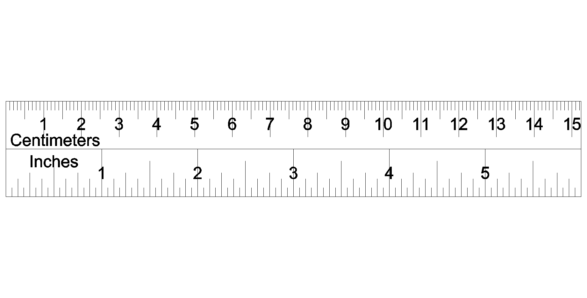

(a) Write the width and length of the rectangle including absolute uncertainties.

**[2 marks]**

Length: _________________ ± __________________

Width: _________________ ± __________________

(b) Calculate the relative (percentage) uncertainty of the ***area*** of the shaded rectangle. Show **ALL** working for full marks.

**[3 marks]**

4. China's 8.50 tonne Tiangong-1 space station has re-entered Earth's atmosphere over the South Pacific and burned up. Its speed on entering the atmosphere was 7.50 kms-1 but dropped to 1.80 kms-1 as it started to break up and burn, having travelled 75.0 km through the atmosphere.

(a) Calculate the amount of work done by the atmosphere in slowing the space craft.

**[3 marks]**

(b) Determine the average force of friction that was applied as it slowed down. **[3 marks]**

5. During a BBL cricket match in Perth, a ball bowled at the batter reaches him at 36.0 ms-1 but is struck by the bat and leaves its face at 43.0 ms-1. Assuming that the 163 g ball rebounds along the same path and is in contact with the bat for 0.220 s, calculate:

(a) the change in velocity of the ball. **[3 marks]**

(b) the impulsive force applied by the bat onto the ball. **[3 marks]**

6. Sue wants to lower the temperature of her stainless steel barbecue plate from 4.00 x 102 oC to 1.80 x 102 oC by spraying water directly onto the 25.0 kg plate.

Calculate the mass of water, initially at 20.0 oC, required to cool the barbecue plate.

Assume all water completely evaporates to steam at 1.00 x 102 oC and that there is no energy lost to the environment. The specific heat capacity of the stainless steel is

4.50 x 102 Jkg-1K-1. **[4 marks]**

7. An elevator car has a mass of 1.60 x 103 kg and it is carrying four passengerswith a total combined mass of 2.00 x 102 kg. A frictionforce of 4.00 x 103 N acts constantly to retard its motion upward. What power is delivered by the motor to lift the elevator car at a constant speed of 3.00 ms-1? **[4 marks]**

8. For the next **TWO** questions, circle the letter in front of the correct answer. **[2 marks]**

(i) Which of the following is the reaction force to the gravitational force acting on your body as you sit in a chair?

a. The normal force exerted by the chair.

b. The force you exert downward on the seat of the chair.

c. The gravitational force of your body acting on the Earth.

d. None of these forces.

(ii) You are talking by interplanetary telephone to your friend, who lives on the Moon. He tells you that he has just won one newton of gold in a contest. Excitedly, you tell him that you entered the Earth version of the same contest and also won a newton of gold! Who won the most gold?

a. your friend.

b. you.

c. the same amount of gold was won by both of you.

9. The Slingshot ride at Cedar Point fires two people in a capsule vertically into the air initially at 1.00 x 102 kmh-1.

(a) Theoretically, how high do the passengers rise in the air? **[3 marks]**



(b) In reality, passengers are lifted to 1.10 x 102 m by the specially-designed 720 springs. ***Estimate*** the amount of work done in moving the capsule and passengers to this height. List any assumptions. **[4 marks]**

10. Two substances with the same mass are made up of pure metals. One is pure gold and another one is pure copper. The specific heat capacities of gold and copper are 130 Jkg-1K-1 and 390 Jkg-1K-1, respectively.

(a) Explain what it is meant by 130 Jkg-1K-1. **[2 marks]**

(b) With the same amount of energy being transferred to each metal, which metal will have the greatest change in temperature? Use appropriate formulae to support your answer. **[3 marks]**

11. Playgrounds in Bunnings stores have recycled soft rubber around the equipment as a safety feature. With reference to your knowledge of change in momentum and force, explain how the soft rubber protects children. **[3 marks]**

12. A person of mass 75.0 kg is standing in a lift in an office tower. Calculate his apparent weight when:

(a) the lift is moving downwards at a constant velocity. **[3 marks]**

(b) the lift is decelerating to a stop at 1.70 ms-2 when it nears the ground floor of the building, having moved down from the top floor. **[3 marks]**

13. Students are using model cars to test the effects of collisions on a frictionless track. A red car of mass 8.00 kg is moving East at 12.0 ms-1 when it collides with a blue car of mass

5.00 kg travelling West at 9.00 ms-1. After the collision, the red car is moving East at

2.50 ms-1.

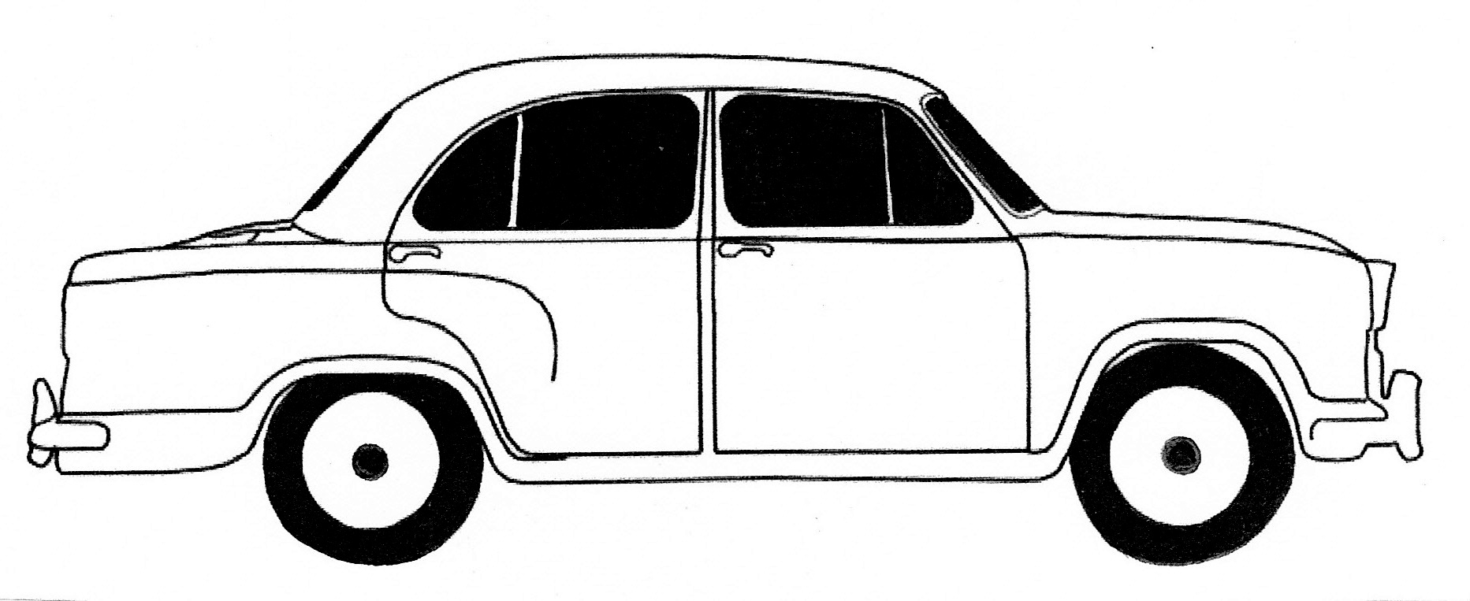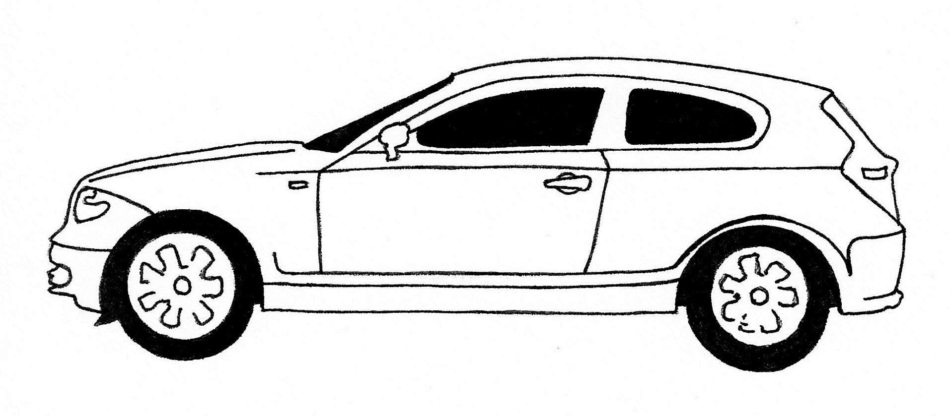

8.00 kg 12.0 m s-1

5.00 kg 9.00 m s-1

blue

red

(a) Determine the velocity of the blue car after the collision. **[3 marks]**

(b) The kinetic energy of the cars after the collision is 121 J. Compare this with the kinetic energy of the cars before the collision. What conclusion can you make about energy transformations in the collision? **[3 marks]**

14. A person's car battery has run flat. In an attempt to "jump start" the car, another person tries to push it along a level driveway while the driver tries to start it.

(a) Why is it so hard or difficult to start the car moving? **[2 marks]**

(b) It becomes easier to move the car once it is rolling. Why is this? **[2 marks]**

15. A crane in a junk yard lifts a damaged car, which has a mass of 2.00 x 103 kg, to a height of 3.00 m. above the ground. On the axes below, sketch a graph to show how the weight of the car (y axis) varies with the height it is lifted above the ground (x axis). Label the axes carefully. **[4 marks]**

**THIS PAGE HAS BEEN DELIBERATELY LEFT BLANK.**

**SECTION TWO: Problem Solving**

**Marks allotted: 87 marks out of 175 marks total.**

Attempt ALL 6 questions in this section. The marks allocated to each question are given and the answers should be written in the spaces provided.

**[16 marks]**

16. A motorbike is stationary at a set of traffic lights. It accelerates uniformly to 18.0 ms-1 in

8.0 s before maintaining its speed for another 22.0 s. At this point it accelerates uniformly to 28.0 ms-1 in 4.0 s to pass a car before braking uniformly to come to a stop at a traffic sign in 6.0 s.

(a) Draw a velocity-time graph for the motion of the motorbike, including scales and labels on the axes. (Assume the motion is in a straight line.) **[4 marks]**

prac exam youngs mod 10 by 10

(b) From the graph, determine the distance between the traffic lights and the stop sign.

**[5 marks]**

(c) Draw an acceleration – time graph of this motion, giving ***clear scales*** on each axis. You may need to do some calculations. Use the spare pages at the end of this answer booklet. **[7 marks]**

prac exam youngs mod 10 by 10

**[15 marks]**

17. Consider the 1887 water slide shown in the diagram below. Arider on a small sled with a total mass 80.0 kg, can push off tostart at the top of the slide (point **A**) with a speed of

**A**

**B**

**C**

2.50 ms-1.

The chute was 9.76 m high at the top,

**A**

**B**

**C**

54.3 mlong and 0.51 m wide. Along its length, 725 wheels made friction negligible.

Upon leaving the chute horizontally at its bottom end (point **C**), the rider skimmed across the water for as much as 50.0 m, “skipping along like a flat pebble”, before coming to rest.

(a) Using the principle of conservation of mechanical energy, find the speed of the sled and rider at point **C**. **[3 marks]**

(b) The force of the water friction behaves as a constant retarding force acting on the sled. Calculate the work done by water friction in stopping the sled and rider. **[3 marks]**

(c) Determine the magnitude of the average force the water exerts on the sled as it slows down to a stop over 50.0 m. **[3 marks]**

(d) Calculate the angle of the chute. **[1 mark]**

(e) Draw a free body diagram showing the forces acting on the sled and rider at point **B**?

**[2 marks]**

(f) Using your answers to part (d) and (e), determine the magnitude of the force accelerating the sled down the chute at point **B**. **[3 marks]**

**[14 marks]**

18. This question requires data analysis. The context of thermal conduction is related to the syllabus, but detailed knowledge is not required.



When heat flows along a good conductor (e.g. a metal), the heat flow ***Q*** in time ***t*** is related to the length ***L*** of the metal bar, the temperature difference (***Φ2 - Φ1***) between the ends and its cross-sectional area ***A*** by the equation:

$\text{Q = }\frac{\text{kA(}{\text{Φ}}_{\text{2}}\text{ - }{\text{Φ}}_{\text{1}}\text{)t}}{\text{L}}$

***k*** is a constant that varies from metal to metal and is known as the ***coefficient of thermal conductivity***.

In an experiment, it is assumed no heat is lost from the sides of the metal bar and this is achieved by extensive insulation.

In an investigation to determine the thermal conductivity of a metal, the following results were obtained. The bar had length of 0.75 m, a cross-sectional area of 0.65 m2 and the time of heating was 2.0 minutes.

(a) Fill in the right-hand column with the values for Φ2 -Φ1. **[2 marks]**

|  |  |  |  |
| --- | --- | --- | --- |
| **Heat (Q) added**  **(x 105 J)** | **Temperature**  **2 (°C)** | **Temperature**  **1 (°C)** | **2 - 1**  **(°C)** |
| 7.6 | 80 | 55 |  |
| 3.8 | 70 | 57 |  |
| 2.2 | 55 | 49 |  |
| 2.9 | 40 | 31 |  |
| 4.5 | 35 | 20 |  |

(a) Plot a graph of heat added (y-axis) against temperature difference (Φ2 -Φ1)

(x-axis). Draw the line of best fit. **[4 marks]**

prac exam youngs mod 10 by 10

(b) Calculate the gradient of the line of best fit. **[4 marks]**

(c) Use the gradient to determine the coefficient of thermal conductivity (***k***). **[4 marks]**

***Note: A spare graph paper is at the back of the booklet if you need it.***

**THIS PAGE HAS BEEN LEFT BLANK DELIBERATELY.**

**[16 marks]**

19. The follow graph shows the cooling curve of 1.00 kg of naphthalene from liquid to solid over 18.0 minutes. The naphthalene releases energy at a rate of 3.50 x 102 W as it cools from 90.0 oC.



(a) On the graph above, label the time when the naphthalene is in a liquid state.

**[1 mark]**

(b) Use the kinetic theory of matter to explain why the curve stays flat between

3.0 minutes and 11.0 minutes. **[3 marks]**

(c) A value for the latent heat of fusion can be found using the curve.

(i) Calculate the total energy released between 3.0 minutes and 11.0 minutes.

**[2 marks]**

(ii) Hence, determine a value for the latent heat of fusion for naphthalene.



**[3 marks]**

(d) Use the graph to ***estimate*** the specific heat capacity of the solid naphthalene.

**[4 marks]**

(e) On the graph below, redraw new cooling curves when the following conditions have changed:

• the mass of the naphthalene is doubled.

• the rate of energy lost is the same as before and the initial temperature stays at 90.0 oC.

***[An additional graph is available at the back of this booklet.]*** **[3 marks]**

**[12 marks]**

20. A boy on the first floor of the Middle School building at his school yells down to his friend to throw back up his lunchbox that had fallen over the rail. His friend throws it vertically upwards and it goes to a height of 5.00 m before falling back down so that the boy catches it 3.90 m above its release point. (Ignore any sideways movement.)

(a) Calculate the velocity of the lunchbox at release if it is to make it up 5.00 m above its release point. **[3 marks]**

(b) What is the velocity of the lunchbox when it is caught? **[3 marks]**

(c) How long is the lunchbox in flight? **[2 marks]**

(d) Draw a velocity-time graph for this motion. Include accurate scales and labels on the axes. **[4 marks]**

prac exam youngs mod 10 by 10

**[14 marks]**

21. Following the failure of its engine, a remote-controlled model aeroplane of mass 4.20 kg

plummets towards the Earth and hits the ground with a vertical velocity of 25.0 ms-1.

(a) By how much does the Earth’s momentum change as a result of the aeroplane hitting

the Earth’s surface? (Hint: Consider the change in momentum of the plane.) **[3 marks]**

(b) How much energy is released when the aeroplane hits the Earth? **[2 marks]**

(c) By how much does the velocity of the Earth change due to the collision with the

aeroplane? (Mass of the Earth = 5.98 x 1024 kg)  **[3 marks]**

(d) If the aeroplane and the Earth were in contact for 0.750 s during the collision impact,

what is the force exerted by the Earth onto the plane? **[3 marks]**

(e) If the aeroplane was travelling horizontally before its engine failed, ***estimate*** the

altitude at which it was flying at that time. List any assumptions that you make.

**[3 marks]**

**SECTION C: Comprehension and Interpretation**

**Marks Allotted: 18 marks out of 175 marks total.**

Read the passage carefully and answer all of the questions at the end. Candidates are reminded of the need for correct English and clear and concise presentation of answers. Diagrams (sketches), equations and/or numerical results should be included where appropriate.

**[18 marks] When the weather warms up, pop on cooling clothes**

***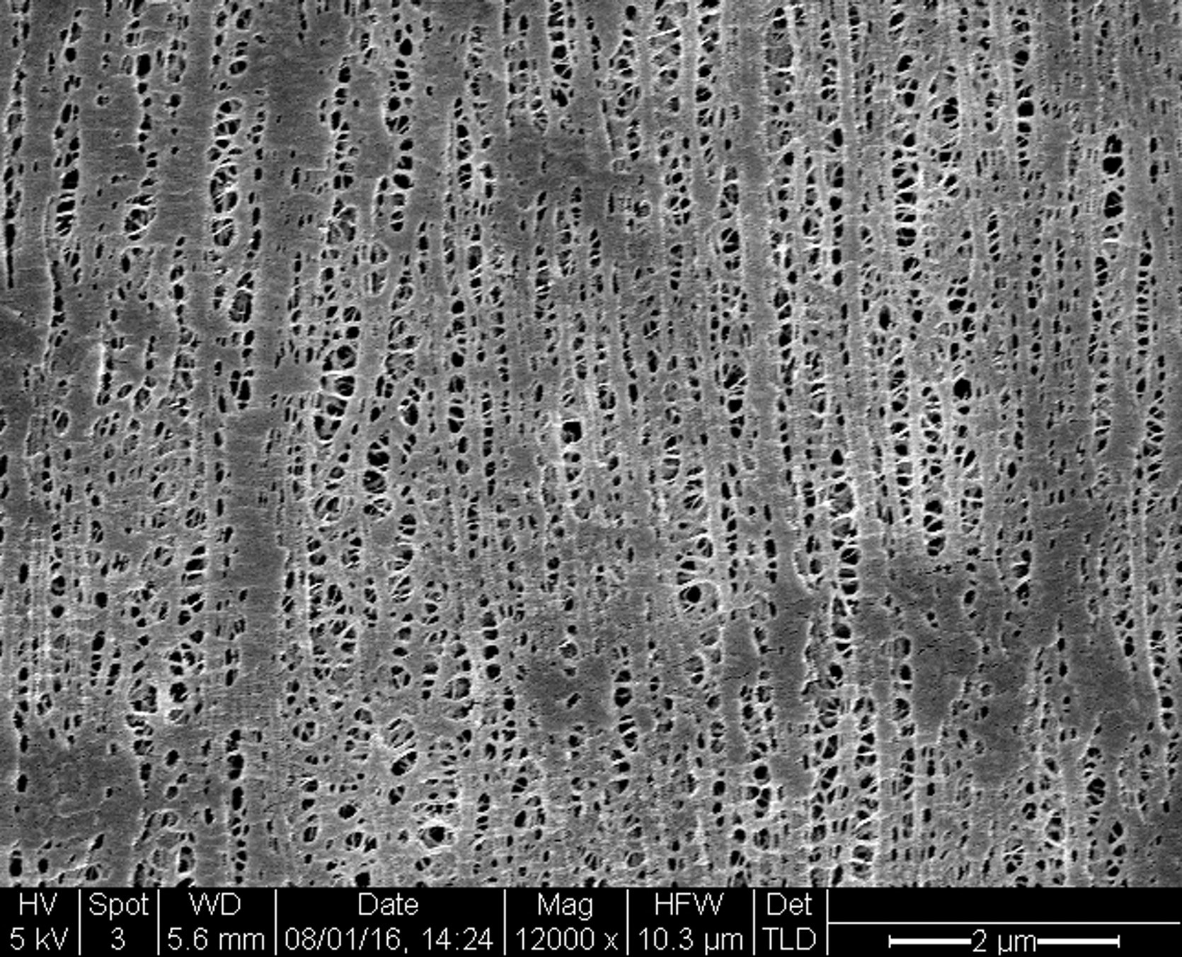****You might add layers when the thermostat drops, but could clothing actually help you cool off too? Stanford University researchers have found a way. Anthea Batsakis reports.*

**Para. 1**

In hot weather, we can only shed so many layers of clothes before it starts to get rude – but now a low-cost material has been invented that cools you down when you start heating up.Developed by researchers at Stanford University, the material reflects sunlight from the body while providing an escape route for heat radiating from our skin.

**Para. 2**

The fabric is a creative substitute for air conditioning or other indoor cooling devices, Po-Chun Hsu, Yi Cui and colleagues write in Science. They hope the material can be developed on a commercial scale and have a global impact by reducing greenhouse gas emissions.

Figure 1 An electron microscope image of the cooling material. The tiny pores let sweat evaporate.

**Para. 3**

The human body emits mid-infrared radiation. But this is the core of the cooling problem – wavelengths of our infrared emissions sit so close to visible light on the electromagnetic spectrum, the two overlap a little. This means regular clothes that block visible light from entering also trap body heat. The cool fabric from Stanford, though, lets infrared through, lowering temperatures between 2 °C and 3 °C. It also facilitates air and water vapour flow, making things more manageable when we sweat. It’s made of a flexible and durable version of the thin plastic film you might use in the kitchen to cover food called polyethylene. But unlike cling film, the new material is treated with safe chemicals to create nanoporous polyethylene, which lets water evaporate through tiny pores.

**Para. 4**

Compared to pure cotton, though, the material is far more “breathable”: cotton only allows 1.5% of infrared waves to pass, while the porous polyethylene clears the way for 96% of infrared waves radiated from our skin. ***[The remaining heat stays in the human body.]*** Peter Musk, who also seeks to find sustainable clothing alternatives at the State Library of Queensland in Australia, says it’s important to consider the costs developing this material would have. “This new polyethylene product may well reduce the need for energy use by the end user, but analysis of the total cost to the environment, and greenhouse gas emissions involved in mining, transporting, refining and manufacturing the product might produce a different conclusion about its contribution to sustainability,” Musk says.

**Para. 5**

In any case, instead of cranking up the air conditioning, you might one day change your clothes instead. The scientists are working on adding more colours and textures to their range over the next few months.

22 (a) Explain how the cool fabric from Stanford University might contribute to reduced greenhouse gas emissions. **[3 marks]**



(b) Outline three differences between pure cotton and the cool fabric in terms of cooling the body. **[3 marks]**

|  |  |
| --- | --- |
| **Pure cotton** | **Cool fabric** |
|  |  |
|  |  |
|  | . |

(c) Use kinetic theory to explain how evaporation of water from the human body can cause cooling.  **[2 marks]**

(d) John, a 75.0 kg runner, generates 8.00 MJ of energy while training for a marathon.

(i) Calculate the temperature rise of John’s body if he is wearing the cool fabric. Assume the specific heat capacity of an average human body is

3.50 x 103 Jkg-1K-1. Use data in paragraph four to assist your calculation. **[4 marks]**

(ii) ***Estimate*** the mass of water needed to evaporate from John’s body to maintain a constant body temperature during this run. Assume evaporation occurs at the same temperature as John’s body. **[4 marks]**

(iii) Describe the difference it would make to John’s body if he were to wear cotton clothes instead. No calculations are required. **[2 marks]**

**END OF EXAMINATIONADDITIONAL WORKING SPACE**

**ADDITIONAL WORKING SPACE**

prac exam youngs mod 10 by 10

**ADDITIONAL WORKING SPACE**

**ADDITIONAL WORKING SPACE**